Auto-Scaling Lab

Contents

Auto-Scaling Lab for Liberty 3

1.1 Enable Auto Scaling 5

1.2 Package and Deploy Dynamic Cluster 7

1.3 Testing Auto Scaling 12

1.4 Changing Scaling Policy 17

1.5 Clean up 23

1.6 Summary 24

Appendix A. Notices 25

Appendix B. Trademarks and copyrights 27

# **Auto-Scaling Lab for Liberty**

Auto scaling provides an autonomic scaling capability of Liberty servers. The auto scaling functionality is enabled by two Liberty features, **scaling controller** and **scaling member**. Auto scaling dynamically adjusts the number of Java virtual machines (JVMs) used to service your workload. This feature provides operational agility and decreases administrative overhead to enhance the resiliency of your middleware environment.

The conditions for auto scaling are defined by scaling policies. These conditions include the minimum or maximum number of server instances and the threshold values for each of the server resources.

In this lab exercise, you will learn:

* How to use the auto-scaling feature that automatically starts and stops JVM instances based on scaling policy.

This lab runs only on the Windows amf Linux platform as only those versions of the web server and plugin are included. You may tailor this lab to run with other platforms by downloading the correct version of the Apache web server, and the WebSphere Plugin.

You can download the trial version of the plugin here:

<http://www.ibm.com/developerworks/downloads/ws/wasnetwork/>

As prerequisites, you should:

* Complete **Admin Center lab** to set up the collective controller. Or execute the buildCollective.sh script for Linux or Mac.
  + cd {LAB_HOME}/lab/management/ 4_AutoScaling_<timestamp>
  + ./buildCollective.sh –d {LAB_HOME} –h <hostname> -u <rpcUser> -p <prcUserPassword>
    - If running on MAC, edit the script to remove –-hostJavaHome= from the updateHost command, which is the last line in the script.
  + This will build out, create packagedServer directory, copy dynamic* folders and start the adminCenterController server.
* **(Optional)** Complete the **Dynamic Routing lab**. Even though this lab does not use dynamic routing to demonstrate auto-scaling, dynamic routing is required in a production environment to route requests correctly as the auto-scaling feature adjusts the number of running JVM instances.

To run this lab, your workstation must meet the following requirements:

* Approximately 8GB of storage available for the Windows 7 virtual image
* Approximately 3 GB of memory free to run the developer workbench and the server
* Connectivity to the internet is NOT required
* Please refer to the following table for file and resource location references on different operating systems.

|  |  |  |
| --- | --- | --- |
| Location Ref. | OS | Absolute Path |
| *{LAB_HOME}* | Windows | C:/WLP_<version> |
| Linux | ~/WLP_<version> |
| Mac OSX |  |

## Enable Auto Scaling

The auto scaling functionality is enabled by two Liberty features, **scaling controller** and **scaling member.**

1. **scalingController-1.0**: The scaling controller feature decides when to expand or contract an auto scaling cluster. Collective controllers are required because they provide administration functionality that leverages the ability of the collective controller to manage the scaling controller. Only one of the running scaling controllers can make decisions.

Note: The scaling controller keeps the last known state of the scaling members. Stopping the scaling controller and changing the state of the scaling members may cause some invalid actions at the scaling controller restart, until the scaling controller has gathered the latest scaling member state.

1. **scalingMember-1.0 :**The scaling member feature monitors the workload within the server and its host, and when needed, it sends this information back to the scaling controller. The scaling member feature must be enabled as a collective member in a collective.

**Note:** All scaling member servers must also belong to a cluster because all policy information is applied at the cluster member.

1. Copy the following files from **{LAB_HOME}\labs\management\4_AutoScaling_<timestamp>** to **{LAB_HOME}\wlp\usr\servers\adminCenterController**
   1. server.xml
   2. scalingpolicy.xml
2. Review the server.xml file. Notice the following new addtions
   1. <feature>scalingController-1.0</feature>

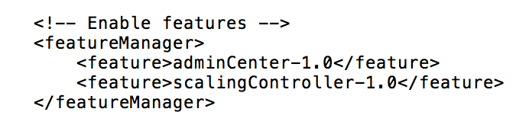

* 1. <include location="${server.config.dir}/scalingpolicy.xml"/>

1. The scalingpolicy.xml file includes the scaling definitions. These values could be added directly to the server.xml, but for clarity it was separated out.

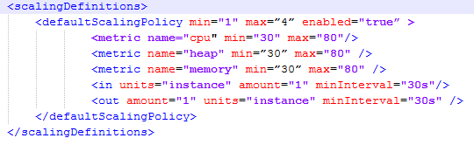

Note that this policy definition overrides the default policy as follows:

* + - 1. If the host CPU or host memory exceed 80% utilization, a new JVM instance is started on another host. [ **We will not demonstrate this function in this lab, which only uses a single host ]**
      2. If the instance heap exceeds 80% utilization, a new JVM instances is started on the same or different host depending on capacity.
      3. If host CPU, host memory, and one JVM heap fall below 30% utilization, the JVM instance is stopped.
      4. Policy decisions are made every 30 seconds.

## Package and Deploy Dynamic Cluster

A packaged server contains **server.xml,** application, and optionally the Liberty runtime. The Admin Center currently only supports packaged server deployment with packages that also contain the runtime. To create a packaged server :

1. Copy **{LAB_HOME}\labs\management\4_AutoScaling_<timestamp>\dynamic_1** directory to **{LAB_HOME}\wlp\usr\servers directory.**

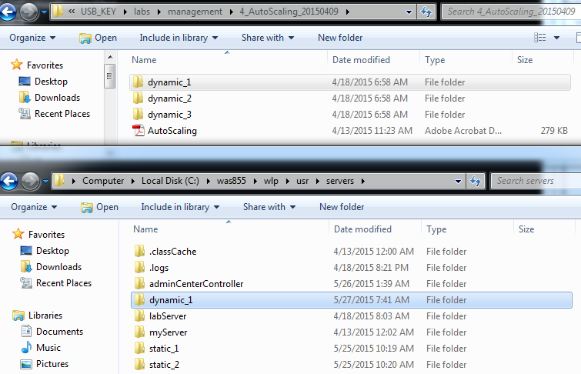

1. Examine the **server.xml** and notice that they include the following features and configuration.
   1. **collectiveMember-1.0:** allows the server to be managed by the controller.
   2. **clusterMember-1.0**: allows the server to be a member of a cluster.
   3. **scalingmember-1.0:** allows to monitor the workload within the server and its host.
   4. **restConnector-1.0:** required for the controller to push policy information down to the application servers**.**
   5. **hostSingleton** definition: By specifying the same port number for all scaling members on the same host, a member is automatically elected as a singleton to gather metrics on the other members on the same host, to send to the scaling controller. If the member acting as the singleton is stopped, another member automatically takes over.



* 1. Use of environment variable **${env.COMPUTERNAME}** to match the hostname.

1. Run the following command to package the server. This creates a **dynamic_1.zip** in the server’s directory. The **minify** option includes only the required features rather than the entire Liberty runtime.

server package dynamic_1 --include=all

1. Ensure that the Admin Controller server is started. If it is not started, execute the following command in a command prompt window: **server start adminCenterController**. Point your browser to <http://localhost:9080/adminCenter>
2. Login to the **Admin Center** with user **admin**, and password **adminpwd.** Click **Submit**

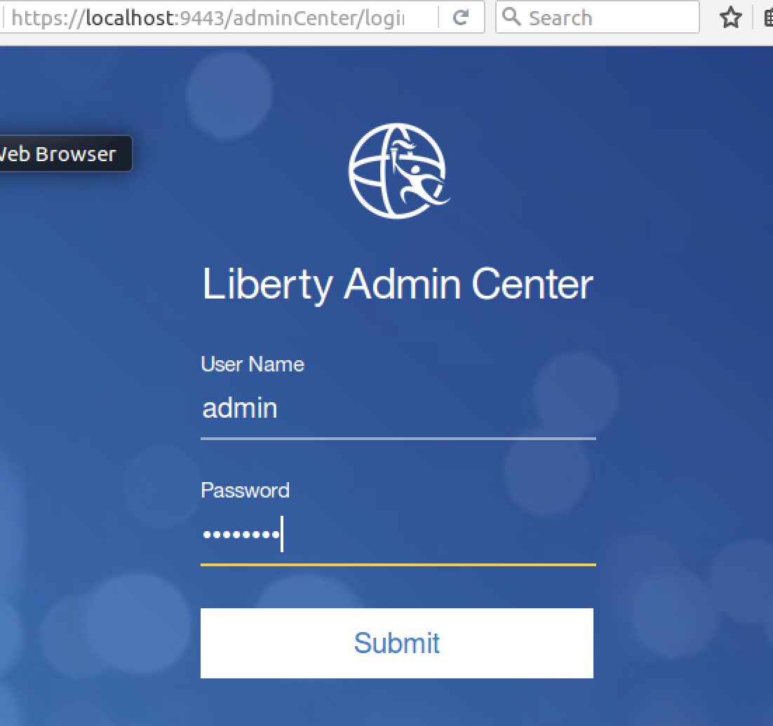

1. Click the **Deploy** icon

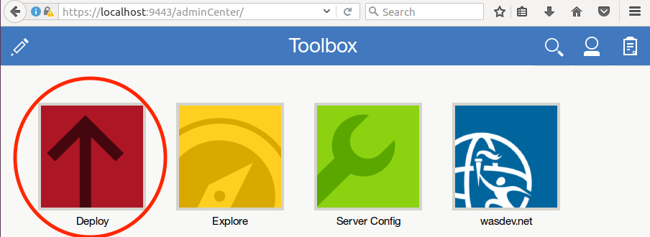

1. On the Deployment Parameters screen, enter the following: NOTE: Currently the Browse button is only functioning for server packages less than 200MB. Because we package the JRE with the server package the Browse button will fail with a file too big. This is slated to be fixed in 17.0.0.3.
   1. Package directory: ***{LAB_HOME}*\wlp\usr\servers\dynamic_1**
   2. Server Package File: **dynamic_1.zip**
   3. Target Directory: ***{LAB_HOME}/*packagedServers** Recall that earlier we ran a **collective updateHost** command to inform the controller what directory we are able to deploy to.

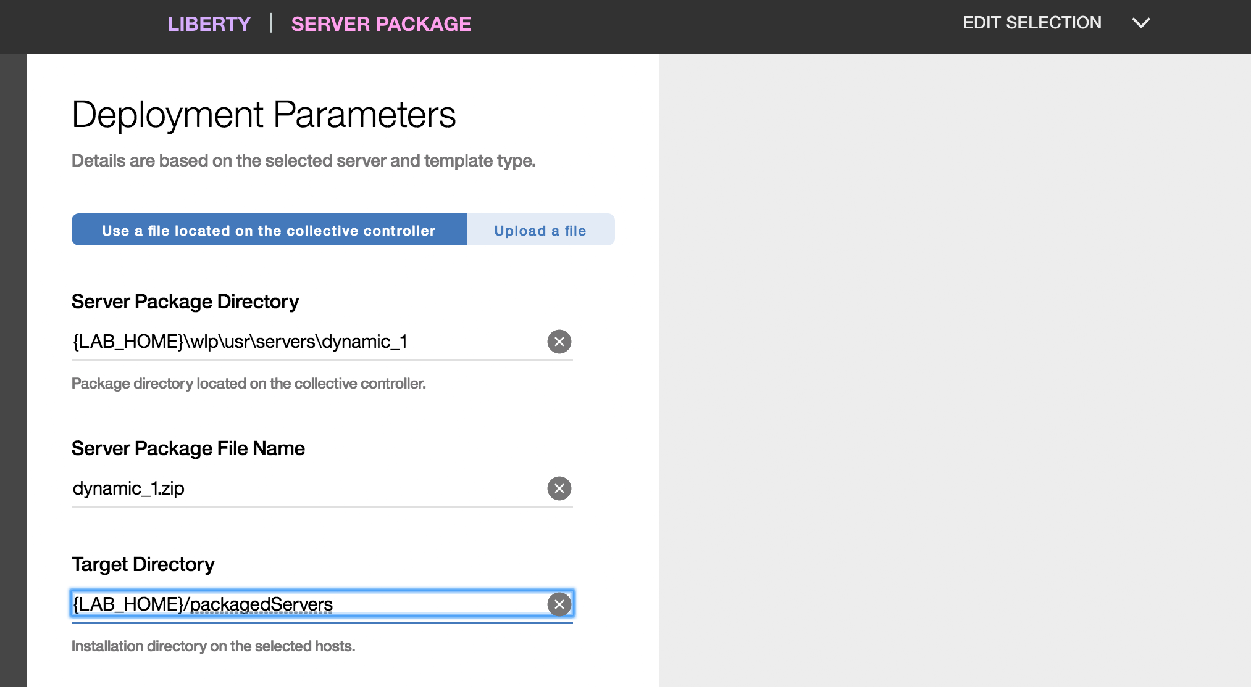

1. Scroll down to select the host. On the right-hand side, click on the appropriate hostname. If you have many hosts, use the search host bar. For this lab, it should be the same as the COMPUTERNAME environment variable that you set. Once clicked it will move to the left and change to 1 selected host

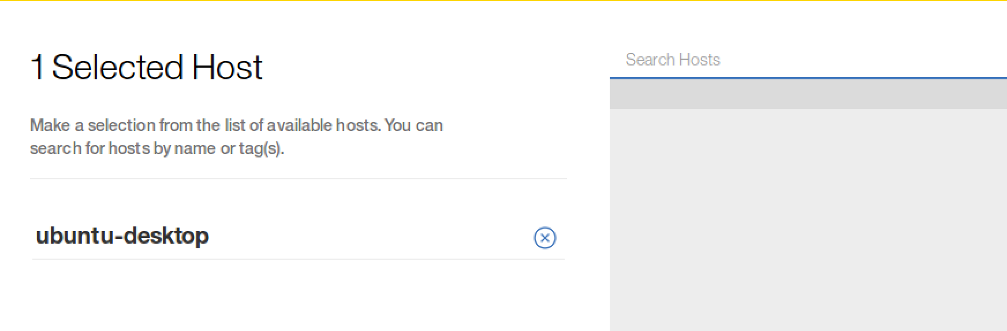

1. Scroll down and enter **labPassword** into the **Keystore Password** and **Confirm Keystore Password** then click the **Deploy** button.

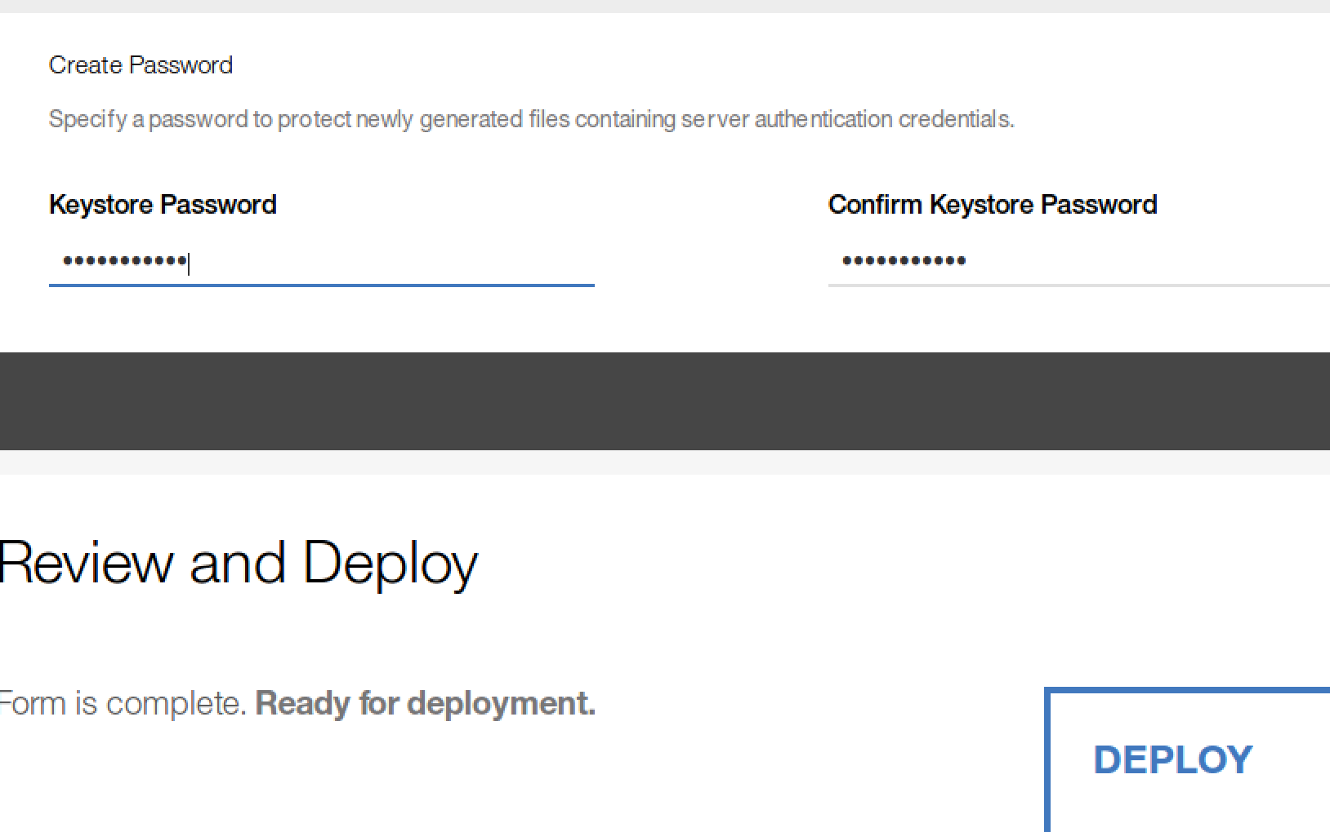

1. Wait for the upload to complete, then click the clipboard icon at the upper-right corner of the window to get to the Task History. Click **Task Details and History** to see the status of the deployment.
2. Problem Determination:
   1. If you get this message: **“CWWKX7204E: Cannot connect to host <host name> with the credentials provided”,** ensure you entered the correct user ID and password. Also ensure you have enabled File and Print Sharing for your network adapter.
   2. If you get a **CWWKX0262E** message, ensure you specified the correct hostReadPath and hostWritePath options when running the **“collective updateHost**” command above. You may re-run the command again with the correct values. Also ensure you specified **{LAB_HOME}/packagedServers/dynamic_1** as the destination directory.
3. A Successful deployment looks like:

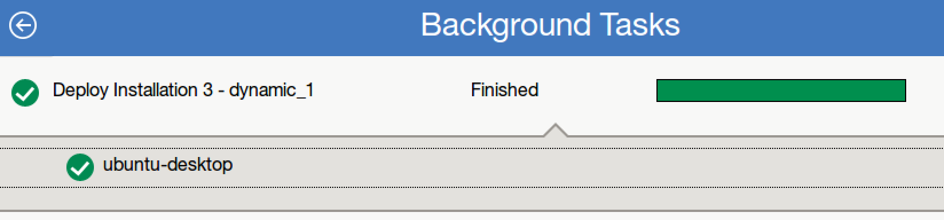

1. Examine what has been deployed by the AdminCenter:
   1. Look at the files in the {LAB_HOME}\packagedServers\dynamic_1\wlp\usr\servers\dynamic _1 directory.
   2. Note that the collective controller creates the configDropins/defaults/additionalConfig.xml that allows the member to join with the controller.
2. Repeat **Step 3** to **Step 19** for **dynamic_2** directory
3. Repeat **Step 3** to **Step 19** for **dynamic_3** directory

## Testing Auto Scaling

1. Go back to the **Explore** view.

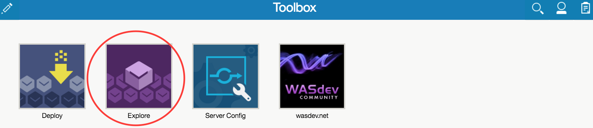

1. Notice that there are now three new servers. However, no cluster has been detected yet.

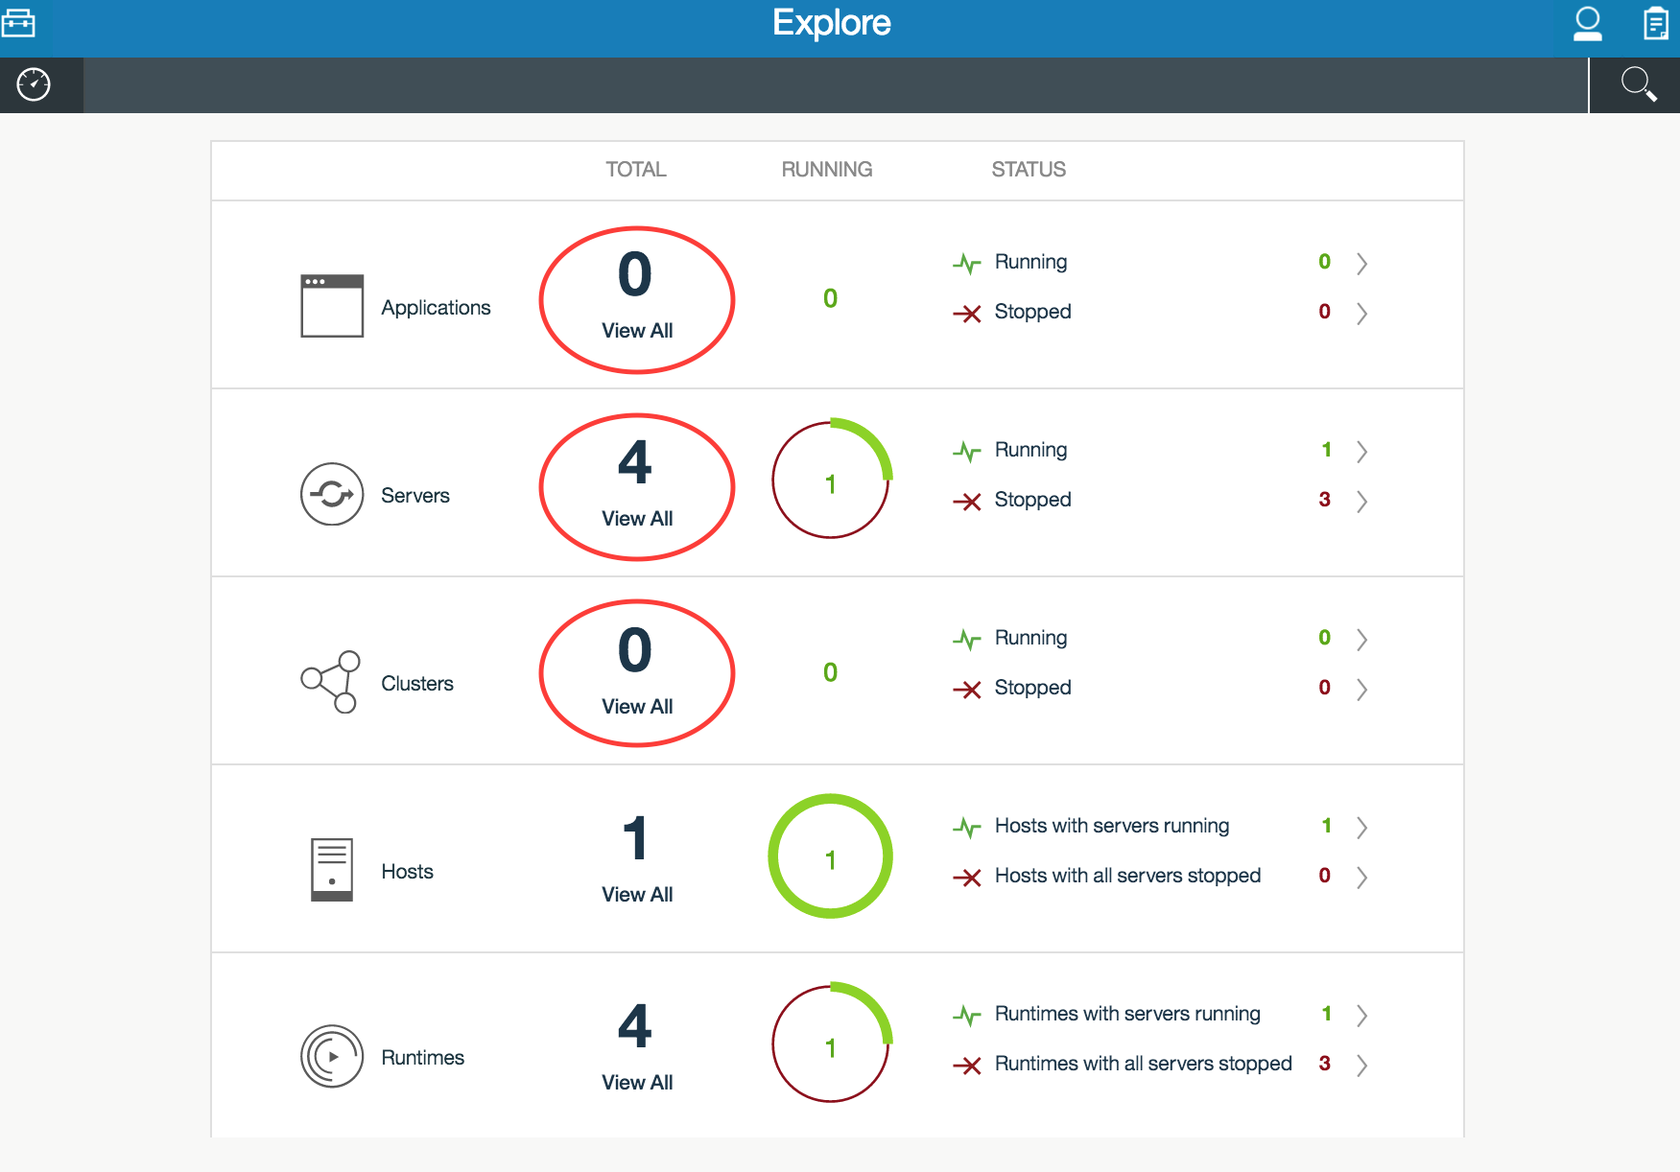

1. Click the **Servers** panel. You should see dynamic_1, dynamic_2 and dynamic_3 in Stopped state.

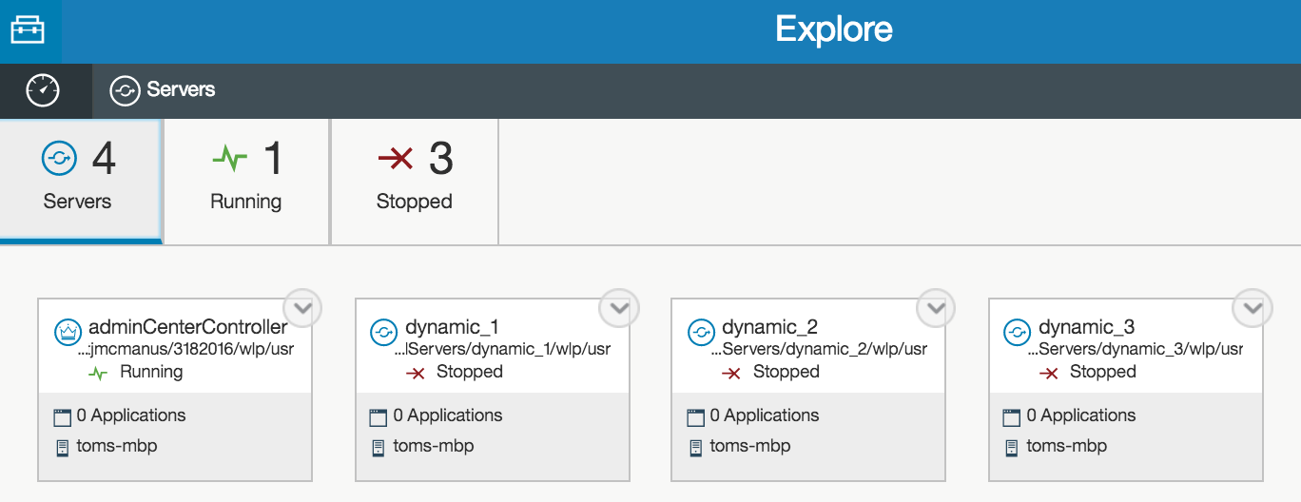

1. Click the  icon on the top-right of the dynamic_1 server box, then click on **Start**

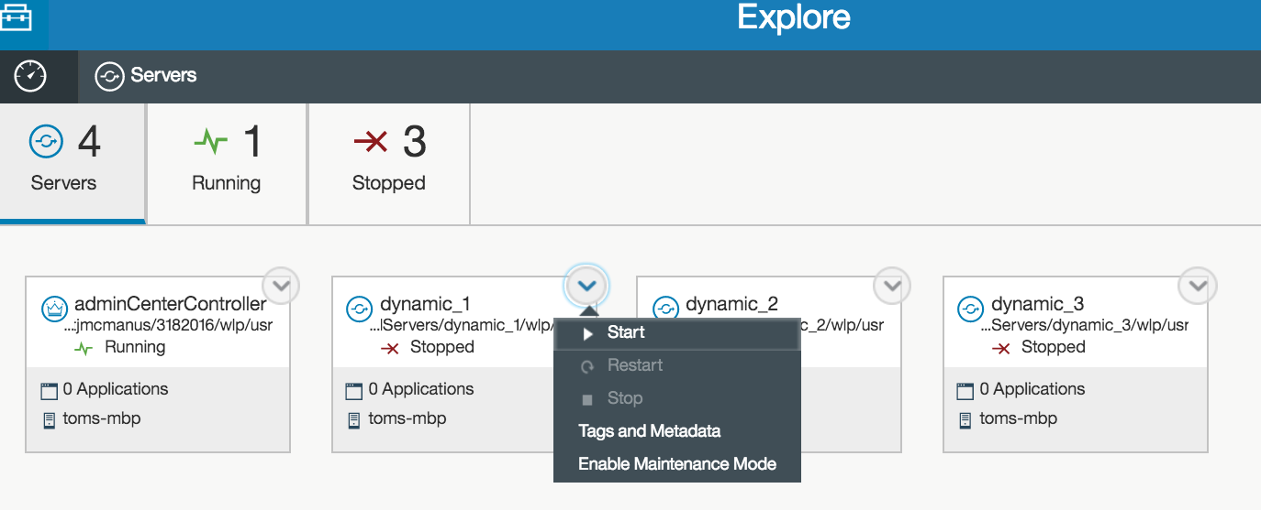

1. Shortly the server status will change to **Running**

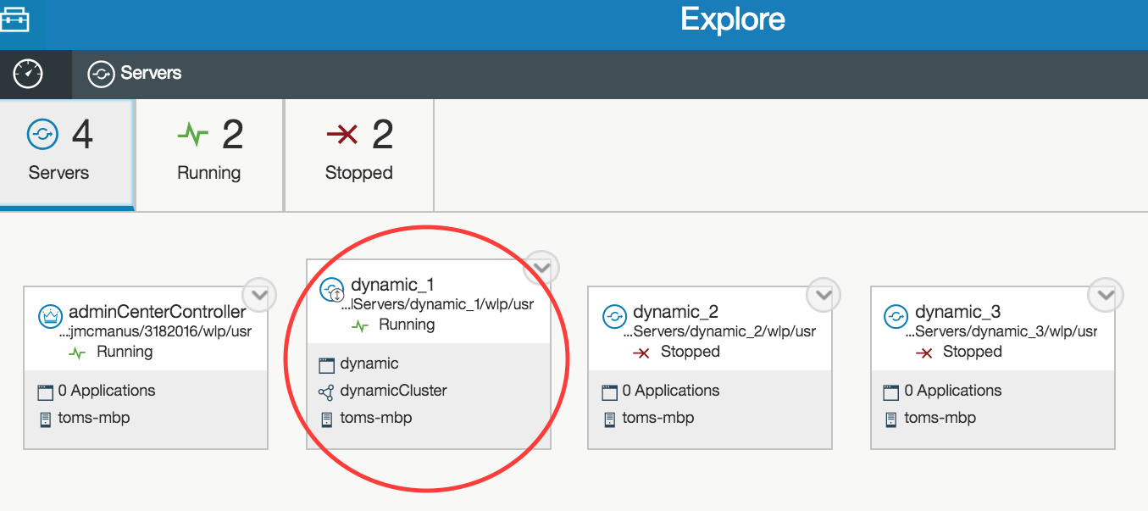

1. Note that a cluster is now detected and the application is running

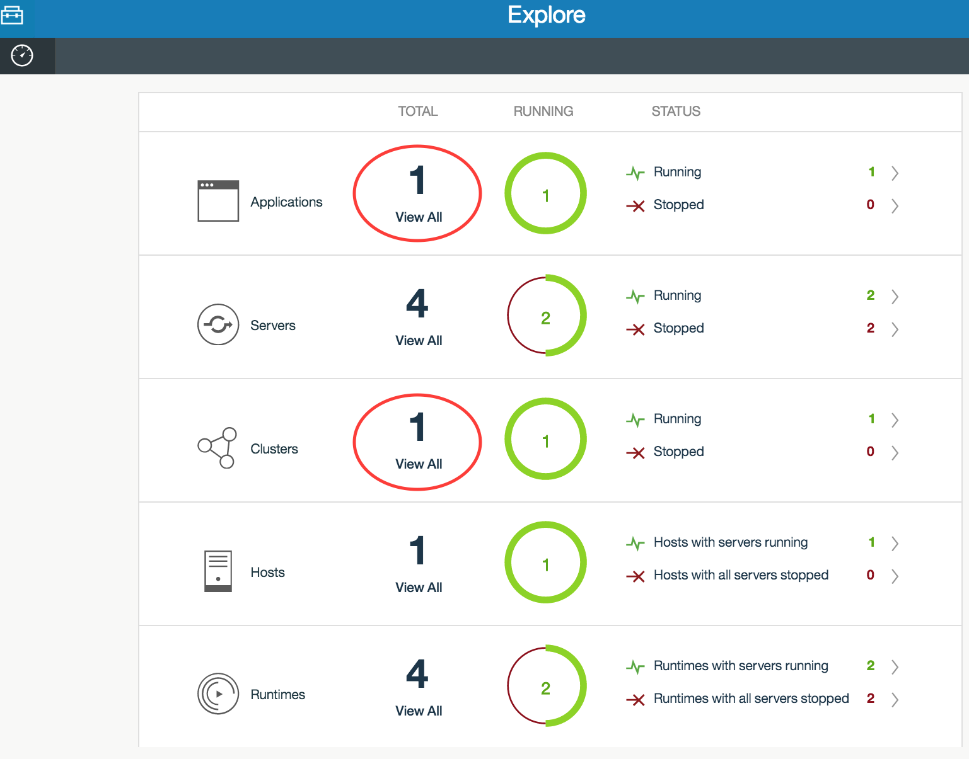

1. Similarly try startingthe servers **dynamic_2** and **dynamic_3**
2. Note that some of the servers may not be started/stopped because of policy breach. However, the breach may not occur on your machine depending on the hardware you have.

For the controller to stop the application server on your hardware based on the policy we have defined, you must have:

* + - * 1. Less than 30% heap being used by the application server
        2. Less than 30% cpu utilization on the host
        3. Less than 30% total memory utilization used on the host

1. To determine whether or not the controller has taken a policy action, look in the **messages.log** file of **adminCenterController**. If it has taken action, the log entries look like :

[5/28/15 6:32:57:385 EDT] 00000061 com.ibm.ws.scaling.controller.internal.ScalingExecutorImpl I CWWKV0115I: The scaling controller is stopping server dynamic_2 in user directory C:/wlp_pot/packagedServers/dynamic_2/wlp/usr on host win7-x64 to reduce capacity in cluster dynamicCluster.

[5/28/15 6:33:30:635 EDT] 00000061 com.ibm.ws.scaling.controller.internal.ScalingExecutorImpl I CWWKV0114I: The scaling controller has successfully stopped server dynamic_2 on host win7-x64.

[5/28/15 6:33:30:344 EDT] 0000002e com.ibm.ws.scaling.controller.topology.RepositoryMonitor I CWWKV0121I: The server dynamic_3 in user directory C:/wlp_pot/packagedServers/dynamic_3/wlp/usr on host win7-x64 has been defined as a scaling member in cluster dynamicCluster.

[5/28/15 6:33:30:344 EDT] 0000002e com.ibm.ws.scaling.controller.topology.RepositoryMonitor I CWWKV0121I: The server dynamic_3 in user directory C:/wlp_pot/packagedServers/dynamic_3/wlp/usr on host win7-x64 has been defined as a scaling member in cluster dynamicCluster.

1. Ensure that the cluster dynamicCluster is running with at least one server.
2. Ensure you can access at least one of the pages.

http://<host>:9191/dynamic/SnoopServlet

http://<host>:9192/dynamic/SnoopServlet

http://<host>:9193/dynamic/SnoopServlet

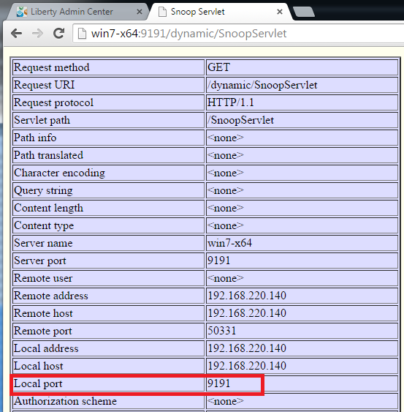

## Changing Scaling Policy

In this section we will demonstrate auto-scaling by changing the scaling policy.

1. From the admin center, navigate to the **Servers** page.
2. Note that you are unable to **start/stop** the servers for dynamic clusters from the admin center. The reason is that you should only have to define the policy and let the scaling controller adjust the number of JVMs.

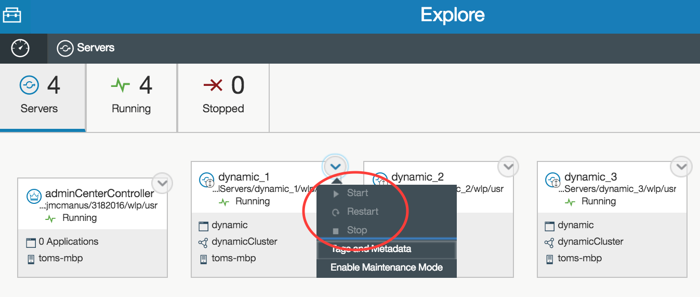

### Test minimum number of servers:

We will test whether the controller maintains a minimum number of servers to be running by stopping all the servers in the dynamic cluster via command line.

|  |  |
| --- | --- |
| sign-info | **Note :**  Some of the servers may already have been stopped by the controller if there was a policy breach for your environment. |

1. Stop dynamic_1
2. Change directory to {LAB_HOME}\packagedServers\dynamic_1\wlp\bin
3. Run the command server stop dynamic_1

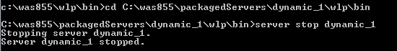

1. Stop server dynamic_2
   1. Change directory to {LAB_HOME}\packagedServers\dynamic_2\wlp\bin
   2. Run the command server stop dynamic_2
2. Stop server dynamic_3
   1. Change directory to {LAB_HOME}\packagedServers\dynamic_3\wlp\bin
   2. Run the command server stop dynamic_3
3. Wait at least 30 seconds and verify the controller has started one instance. You can check status of the server in the admin center, and verify the action in messages.log of the controller:

[5/28/15 7:25:00:572 EDT] 000001fd com.ibm.ws.scaling.controller.internal.ScalingExecutorImpl I CWWKV0111I: The scaling controller is starting server dynamic_2 in user directory C:/wlp_pot/packagedServers/dynamic_2/wlp/usr on host win7-x64 to meet the minimum instances for cluster dynamicCluster.

[5/28/15 7:25:14:417 EDT] 000001fd com.ibm.ws.scaling.controller.internal.ScalingExecutorImpl I CWWKV0112I: The scaling controller has successfully started server dynamic_2 on host win7-x64.

1. Change minimum instances:
   1. Start a text editor and edit saclingpolicy.xml of **adminCenterController.**
   2. Change the minimum instance to 2.

<defaultScalingPolicy min="**2**" max=”4” enabled="true” >

* 1. Save the changes.

1. Verify one more instance has been started by the controller:

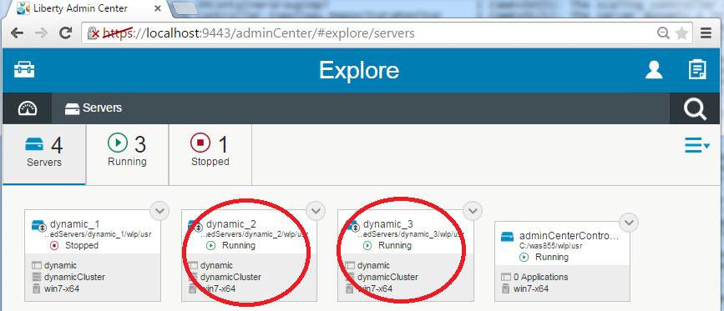

### Testing Scaling-in.

1. If the controller has not previously reduced the number of running instances, it is because one of the following conditions apply to your hardware:
   1. CPU > 30% or
   2. Total memory in use > 30%, or
   3. Heap size of every instance > 30%
2. We can demonstrate scale in by defining an artificial policy designed to force the controller to scale in. Listed below new policy, which sets minimum instance back to **1**, and the minimum CPU/Heap/Memory to be **98%** for scale-in to take place

<scalingDefinitions>

<defaultScalingPolicy min="1" max="4" enabled="true" >

<metric name="cpu" min="98" max="99"/>

<metric name="heap" min="98" max="99" />

<metric name="memory" min="98" max="99" />

<in units="instance" amount="1" minInterval="30s"/>

<out amount="1" units="instance" minInterval="30s" />

</defaultScalingPolicy>

</scalingDefinitions>

|  |  |
| --- | --- |
| sign-info | **Note :**  **The artificial policy is not normally a policy we would define in a working environment** |

1. Save the changes and ensure the controller has taken action to stop one more instance.

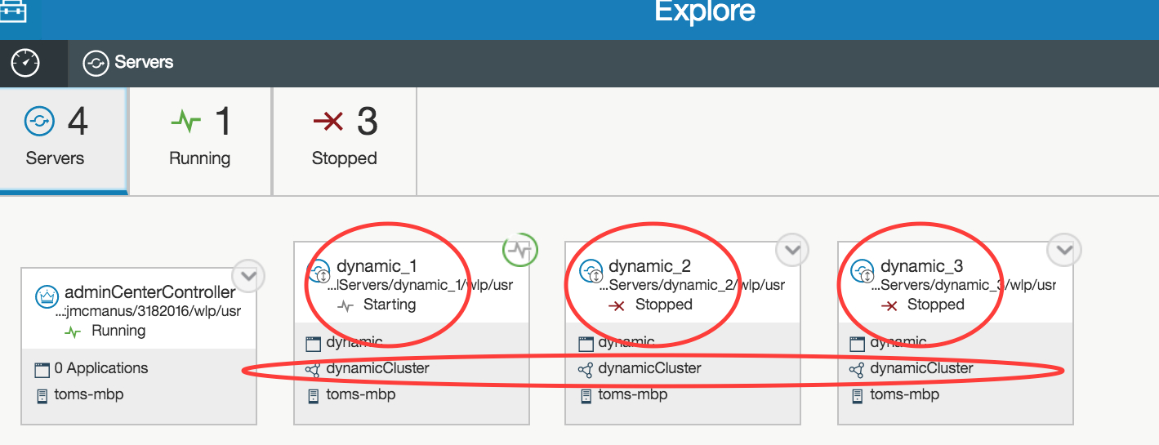

### Test Scale-out:

1. In a normal environment, increasing user workload will increase CPU, total memory, and heap usage to drive a policy breach and cause the controller to start another instance on the same or different hosts.

Due to the constraints of our lab environment, we need to again define an artificial policy to cause a policy breach to scale out. This time, we will make the minimum heap 1%, and maximum heap 2%, which should cause the controller to start more JVM instances:

<scalingDefinitions>

<defaultScalingPolicy min="1" max="4" enabled="true" >

<metric name="cpu" min="30" max="80"/>

<metric name="heap" min="**1**" max="**2**" />

<metric name="memory" min="30" max="80" />

<in units="instance" amount="1" minInterval="30s"/>

<out amount="1" units="instance" minInterval="30s" />

</defaultScalingPolicy>

</scalingDefinitions>

1. Ensure the controller has taken action to start one more instance. This may take up to 30 seconds based on the policy. If you wait 30 seconds longer, the controller should start all the instances as well, as each will be using more than 2% heap.

[5/29/15 3:02:52:059 EDT] 000000c2 com.ibm.ws.scaling.controller.internal.ScalingExecutorImpl I CWWKV0113I: The scaling controller is starting server dynamic_2 in user directory C:/wlp_pot/packagedServers/dynamic_2/wlp/usr on host win7-x64 to increase capacity in cluster dynamicCluster. **The average heap utilization in the cluster is 2.428 percent.**

[5/29/15 3:03:10:220 EDT] 000000c2 com.ibm.ws.scaling.controller.internal.ScalingExecutorImpl I CWWKV0112I: The scaling controller has successfully started server dynamic_2 on host win7-x64.

[5/29/15 3:03:22:075 EDT] 000000c9 com.ibm.ws.scaling.controller.internal.ScalingExecutorImpl I CWWKV0113I: The scaling controller is starting server dynamic_3 in user directory C:/wlp_pot/packagedServers/dynamic_3/wlp/usr on host win7-x64 to increase capacity in cluster dynamicCluster. **The average heap utilization in the cluster is 4.857 percent.**

[5/29/15 3:03:36:115 EDT] 000000c9 com.ibm.ws.scaling.controller.internal.ScalingExecutorImpl I CWWKV0112I: The scaling controller has successfully started server dynamic_3 on host win7-x64.

### Test Cold Start

1. Logout of **admin center** from the browser
2. Stop the **adminCenterController** from command line



1. Stop all the **servers** from the command line.





1. Edit **scalingpolicy.xml** of the controller and reset the scaling policy to the initial one used for this lab.

<scalingDefinitions>

<defaultScalingPolicy min="1" max="4" enabled="true" >

<metric name="cpu" min="30" max="80"/>

<metric name="heap" min="30" max="80" />

<metric name="memory" min="30" max="80" />

<in units="instance" amount="1" minInterval="30s"/>

<out amount="1" units="instance" minInterval="30s" />

</defaultScalingPolicy>

</scalingDefinitions>

1. Save the changes.
2. Start the **adminCenterController**
3. Login to the admin center. Note that it reports the status of all the servers as running. This is the due to the admin center retaining the cached status of the members when it was stopped. Wait a few minutes for the admin center to discover the members are not actually running and update display.
4. Verify that the controller starts at least one member.
5. Try to use cluster specific policy. Note that min has been set to 2 to force minimum of 2 members for dynamicCluster to demonstrate it has taken effect.

<scalingDefinitions>

<scalingPolicy min="2" max="4" enabled="true" >

<bind clusters="dynamicCluster" />

<metric name="cpu" min="30" max="80"/>

<metric name="heap" min="30" max="80" />

<metric name="memory" min="30" max="80" />

<in units="instance" amount="1" minInterval="30s"/>

<out amount="1" units="instance" minInterval="30s" />

</scalingPolicy>

</scalingDefinitions>

## Clean up

Follow the steps in the sections below to clean up the environment and continue with the remaining labs.

1. Disable the policy for the dynamic cluster:

<scalingPolicy min="2" max="4" enabled="false" >

1. Stop all the servers **dynamic_1, dynamic_2**, and **dynamic_3**
2. Un-deploy each server using the instructions in the “**Cleanup”** section of the Admin Center lab.

## Summary

In this lab you have learned:

* How to use the auto-scaling feature on Liberty by editing the scaling policy to :
  + - Maintain minimum number of servers
    - Scale-in
    - Scale-out
    - Cold restart.

1. Notices

This information was developed for products and services offered in the U.S.A.

IBM may not offer the products, services, or features discussed in this document in other countries. Consult your local IBM representative for information on the products and services currently available in your area. Any reference to an IBM product, program, or service is not intended to state or imply that only that IBM product, program, or service may be used. Any functionally equivalent product, program, or service that does not infringe any IBM intellectual property right may be used instead. However, it is the user's responsibility to evaluate and verify the operation of any non-IBM product, program, or service.

IBM may have patents or pending patent applications covering subject matter described in this document. The furnishing of this document does not grant you any license to these patents. You can send license inquiries, in writing, to:

IBM Director of Licensing  
IBM Corporation  
North Castle Drive  
Armonk, NY 10504-1785  
U.S.A.

For license inquiries regarding double-byte (DBCS) information, contact the IBM Intellectual Property Department in your country or send inquiries, in writing, to:

IBM World Trade Asia Corporation  
Licensing  
2-31 Roppongi 3-chome, Minato-ku  
Tokyo 106-0032, Japan

**The following paragraph does not apply to the United Kingdom or any other country where such provisions are inconsistent with local law:** INTERNATIONAL BUSINESS MACHINES CORPORATION PROVIDES THIS PUBLICATION "AS IS" WITHOUT WARRANTY OF ANY KIND, EITHER EXPRESS OR IMPLIED, INCLUDING, BUT NOT LIMITED TO, THE IMPLIED WARRANTIES OF NON-INFRINGEMENT, MERCHANTABILITY OR FITNESS FOR A PARTICULAR PURPOSE. Some states do not allow disclaimer of express or implied warranties in certain transactions, therefore, this statement may not apply to you.

This information could include technical inaccuracies or typographical errors. Changes are periodically made to the information herein; these changes will be incorporated in new editions of the publication. IBM may make improvements and/or changes in the product(s) and/or the program(s) described in this publication at any time without notice.

Any references in this information to non-IBM Web sites are provided for convenience only and do not in any manner serve as an endorsement of those Web sites. The materials at those Web sites are not part of the materials for this IBM product and use of those Web sites is at your own risk.

IBM may use or distribute any of the information you supply in any way it believes appropriate without incurring any obligation to you.

Any performance data contained herein was determined in a controlled environment. Therefore, the results obtained in other operating environments may vary significantly. Some measurements may have been made on development-level systems and there is no guarantee that these measurements will be the same on generally available systems. Furthermore, some measurements may have been estimated through extrapolation. Actual results may vary. Users of this document should verify the applicable data for their specific environment.

Information concerning non-IBM products was obtained from the suppliers of those products, their published announcements or other publicly available sources. IBM has not tested those products and cannot confirm the accuracy of performance, compatibility or any other claims related to non-IBM products. Questions on the capabilities of non-IBM products should be addressed to the suppliers of those products.

All statements regarding IBM's future direction and intent are subject to change or withdrawal without notice, and represent goals and objectives only.

This information contains examples of data and reports used in daily business operations. To illustrate them as completely as possible, the examples include the names of individuals, companies, brands, and products. All of these names are fictitious and any similarity to the names and addresses used by an actual business enterprise is entirely coincidental. All references to fictitious companies or individuals are used for illustration purposes only.

COPYRIGHT LICENSE:

This information contains sample application programs in source language, which illustrate programming techniques on various operating platforms. You may copy, modify, and distribute these sample programs in any form without payment to IBM, for the purposes of developing, using, marketing or distributing application programs conforming to the application programming interface for the operating platform for which the sample programs are written. These examples have not been thoroughly tested under all conditions. IBM, therefore, cannot guarantee or imply reliability, serviceability, or function of these programs.

1. Trademarks and copyrights

The following terms are trademarks of International Business Machines Corporation in the United States, other countries, or both:

|  |  |  |  |  |  |  |
| --- | --- | --- | --- | --- | --- | --- |
| IBM | AIX | CICS | ClearCase | ClearQuest | Cloudscape |  |
| Cube Views | DB2 | developerWorks | DRDA | IMS | IMS/ESA |  |
| Informix | Lotus | Lotus Workflow | MQSeries | OmniFind |  |  |
| Rational | Redbooks | Red Brick | RequisitePro | System i |  |  |
| *System z* | *Tivoli* | *WebSphere* | *Workplace* | *System p* |  |  |

Adobe, Acrobat, Portable Document Format (PDF), and PostScript are either registered trademarks or trademarks of Adobe Systems Incorporated in the United States, other countries, or both.

Cell Broadband Engine is a trademark of Sony Computer Entertainment, Inc. in the United States, other countries, or both and is used under license therefrom.

Java and all Java-based trademarks and logos are trademarks of Sun Microsystems, Inc. in the United States, other countries, or both. See Java Guidelines

Microsoft, Windows, Windows NT, and the Windows logo are registered trademarks of Microsoft Corporation in the United States, other countries, or both.

Intel, Intel logo, Intel Inside, Intel Inside logo, Intel Centrino, Intel Centrino logo, Celeron, Intel Xeon, Intel SpeedStep, Itanium, and Pentium are trademarks or registered trademarks of Intel Corporation or its subsidiaries in the United States and other countries.

UNIX is a registered trademark of The Open Group in the United States and other countries.

Linux is a registered trademark of Linus Torvalds in the United States, other countries, or both.

ITIL is a registered trademark and a registered community trademark of the Office of Government Commerce, and is registered in the U.S. Patent and Trademark Office.

IT Infrastructure Library is a registered trademark of the Central Computer and Telecommunications Agency which is now part of the Office of Government Commerce.

Other company, product and service names may be trademarks or service marks of others.



© Copyright IBM Corporation 2017.

The information contained in these materials is provided for informational purposes only, and is provided AS IS without warranty of any kind, express or implied. IBM shall not be responsible for any damages arising out of the use of, or otherwise related to, these materials. Nothing contained in these materials is intended to, nor shall have the effect of, creating any warranties or representations from IBM or its suppliers or licensors, or altering the terms and conditions of the applicable license agreement governing the use of IBM software. References in these materials to IBM products, programs, or services do not imply that they will be available in all countries in which IBM operates. This information is based on current IBM product plans and strategy, which are subject to change by IBM without notice. Product release dates and/or capabilities referenced in these materials may change at any time at IBM’s sole discretion based on market opportunities or other factors, and are not intended to be a commitment to future product or feature availability in any way.

IBM, the IBM logo and ibm.com are trademarks or registered trademarks of International Business Machines Corporation in the United States, other countries, or both. If these and other IBM trademarked terms are marked on their first occurrence in this information with a trademark symbol (® or ™), these symbols indicate U.S. registered or common law trademarks owned by IBM at the time this information was published. Such trademarks may also be registered or common law trademarks in other countries. A current list of IBM trademarks is available on the Web at “Copyright and trademark information” at ibm.com/legal/copytrade.shtml

Other company, product and service names may be trademarks or service marks of others.

